KJSCE/IT/TYBTECH/SEM-VI/CC/2021-22

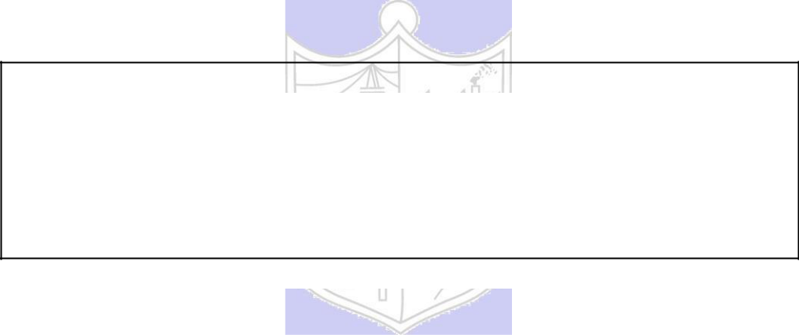

**Experiment No. 2**

**Title: Installation of XEN server and XEN center**

(Autonomous College Affiliated to University of Mumbai)

KJSCE/IT/TYBTECH/SEM-VI/CC/2021-22

**Batch:A4** **Roll No.:1914078** **Experiment No.:2**

**Aim:** Infrastructure as Service – XEN Installation



**Resources needed:** XEN installation set up



**Pre Requisite:** Knowledge of Operating system.



**Theory:**

Xen is a Virtual Machine Monitor (VMM) also known as a hypervisor; this is a software system that allows the execution of multiple virtual guest operating systems simu ltaneously on a single physical machine. Xen is known as a Type 1 or “bare-metal” hypervisor, meaning that it runs directly on top of the physical machine as opposed to within an operating system.



Guest virtual machines running on Xen are known as “domains” and a special domain known as dom0 is responsible for controlling the hypervisor and starting other guest operating systems. These other guest operating systems are called domUs, this is because these domains are “unprivileged” in the sense they cannot control Xen or start/stop other domains.

Xen supports 2 primary types of virtualization, para-virtualization and hardware virtual machine (HVM) also known as “full virtualization”. Para-virtualization uses modified guest operating systems that we refer to as enlightened guests. These operating systems are aware that they are being virtualized and as such don’t require virtual “hardware” devices, instead they make special calls to Xen that allow them to access CPUs, storage and network resources.

In contrast HVM guests need not be modified as Xen will create a fully virtual set of hardware devices for this machine that resemble a physical x86 computer. This emulation requires much more overhead than the paravirtualisation approach but allows unmodified guest operating systems like Microsoft Windows to run on top of Xen. HVM support requires special CPU extensions - VT-x for Intel processors and AMD-V for AMD based machines. This technology is now prevalent and all recent servers and desktop systems should be equipped with them.

**XEN Architecture**

The Xen hypervisor runs directly on the hardware and is responsible for handling CPU, Memory, and interrupts. It is the first program running after exiting the bootloader. On top of Xen we can run a number of virtual machines. A running instance of a virtual machine in Xen is called a domain or guest. A special domain, called domain 0 contains the drivers for all the devices in the system. Stack to manage virtual machine creation, destruction, and configuration.

(Autonomous College Affiliated to University of Mumbai)

KJSCE/IT/TYBTECH/SEM-VI/CC/2021-22

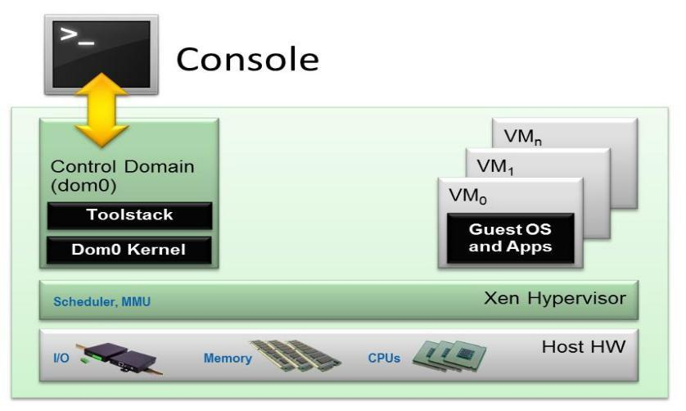

XEN Architecture

∙ **Guest Domains/Virtual Machines** are virtualized environments, each running their own operating system and applications. Xen supports two different virtualization modes: Paravirtualization (PV) and Hardware-assisted or Full Virtualization (HVM). Both guest types can be used at the same time on a single Xen system. It is also possible to use techniques used for Paravirtualization in an HVM guest: essentially creating a continuum between PV and HVM. This approach is called PV on HVM. Xen guests are totally isolated from the hardware: in other words, they have no privilege to access hardware or I/O functionality. Thus, they are also called unprivileged domain (or DomU).



∙ **The Control Domain (or Domain 0)** is a specialized Virtual Machine that has special privileges like the capability to access the hardware directly, handles all access to the system’s I/O functions and interacts with the other Virtual Machines. It also exposes a control interface to the outside world, through which the system is controlled. The Xen hypervisor is not usable without Domain 0, which is the first VM started by the system.

∙ **Toolstack and Console**: Domain 0 contains a control stack (also called Toolstack) that allows a user to manage virtual machine creation, destruction, and configuration. The toolstack exposes an interface that is either driven by a command line console, by a graphical interface or by a cloud orchestration stack such as OpenStack or CloudStack.

* **Xen-enabled operating systems**: A Xen Domain 0 requires a Xen-enabled kernel. Paravirtualized guests require a PV-enabled kernel. Linux distributions that are based on recent Linux kernel are Xen-enabled and usually contain packages that contain the Xen Hypervisor and Tools Xen (the default Toolstack and Console). All but legacy Linux kernels are PV-enabled: in other words, they will run Xen PV guests.

(Autonomous College Affiliated to University of Mumbai)

KJSCE/IT/TYBTECH/SEM-VI/CC/2021-22



**Procedure:**

1. Download ISO file Xen server 6.2 from <https://www.citrix.com/downloads/citrix-hypervisor/product-software/xenserver-70-standard-edition.html>
2. Add a Xenserver as a VM in VM workstation.
3. Download and install Xen Center on windows.
4. Add Xen server in Xen Center.



**Results: (Program / Steps with screenshots)**



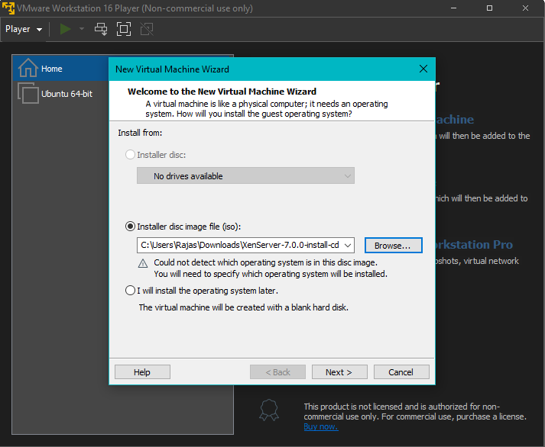

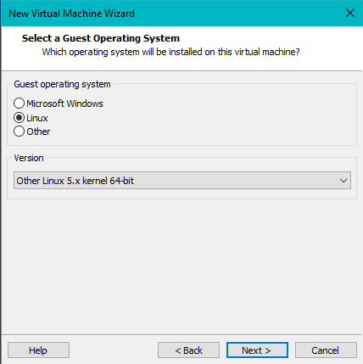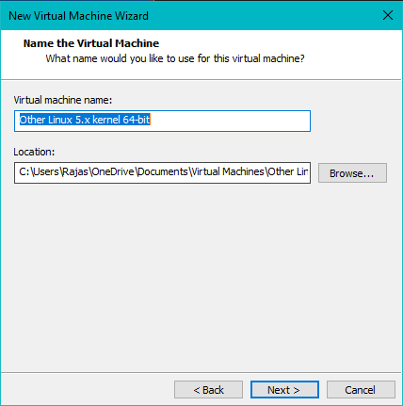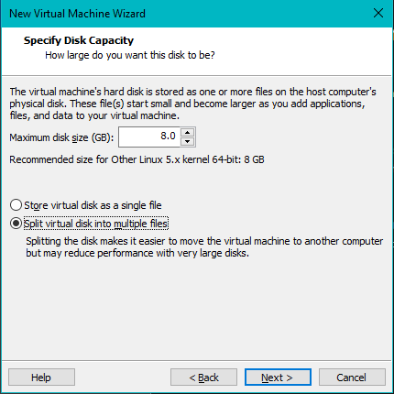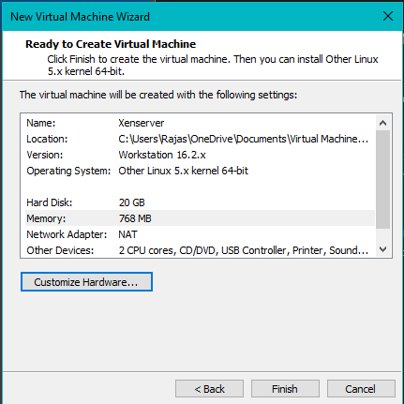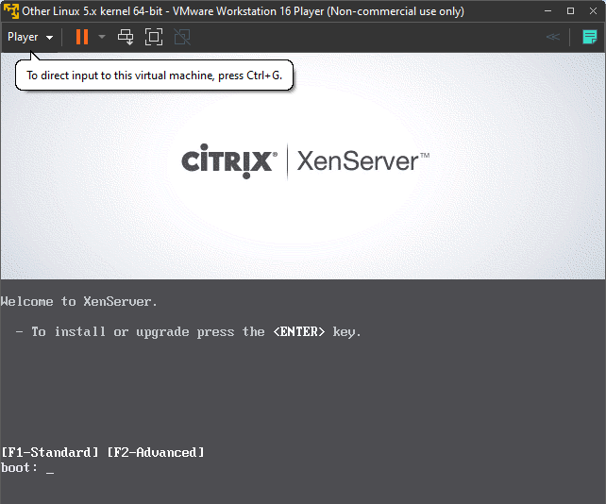

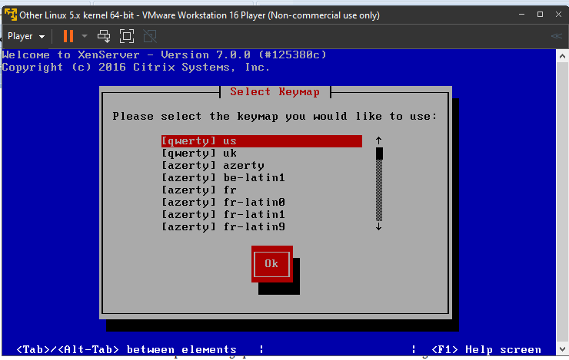

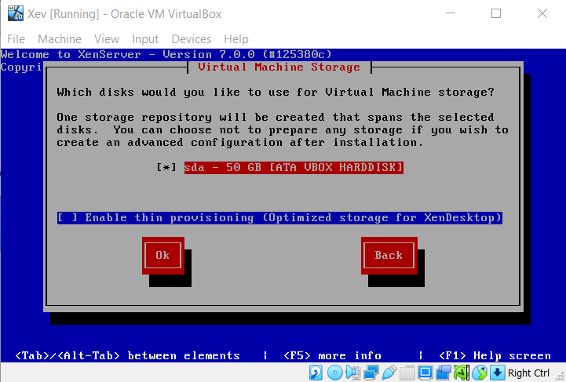

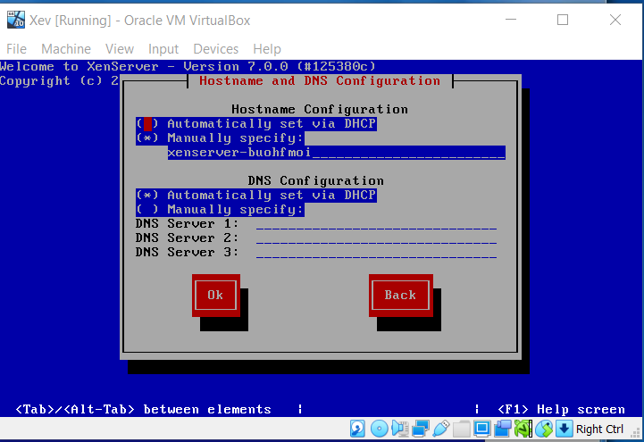

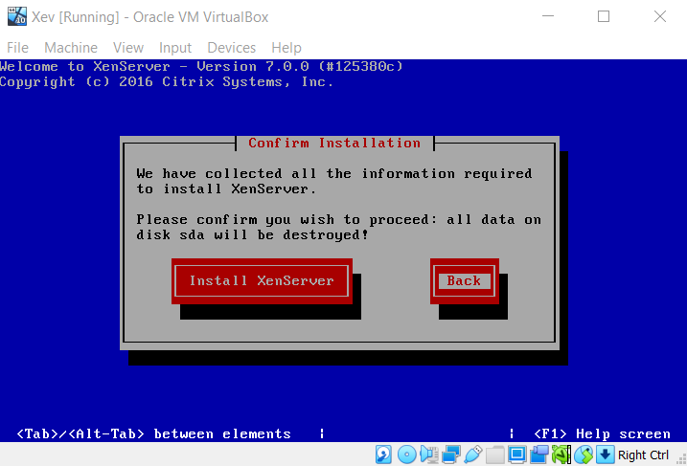

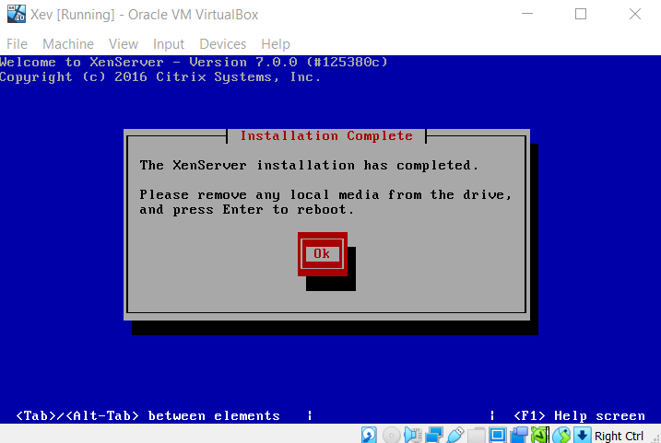

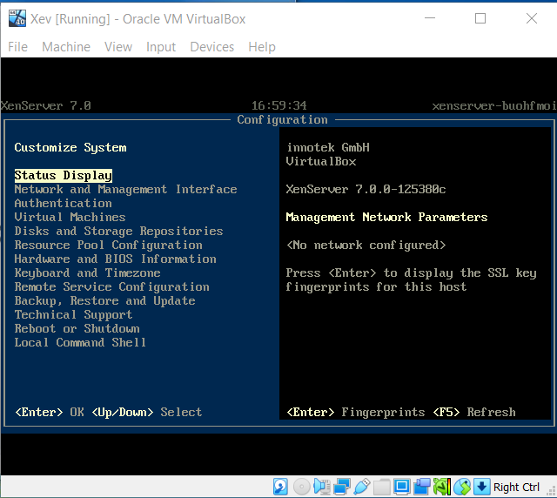

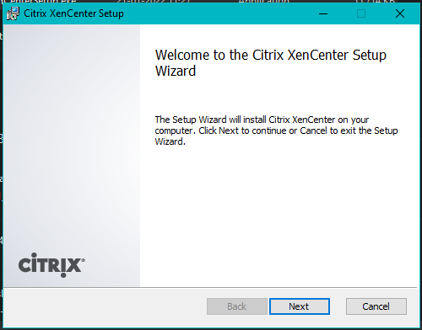

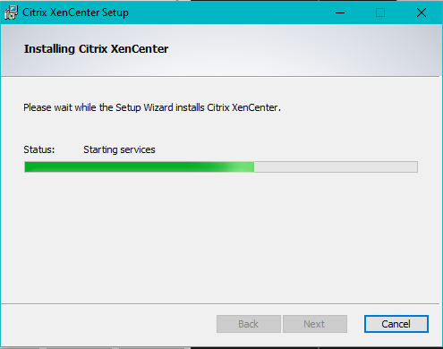

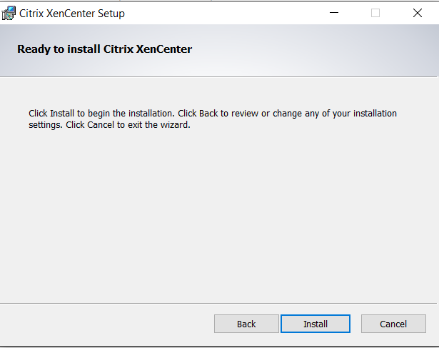

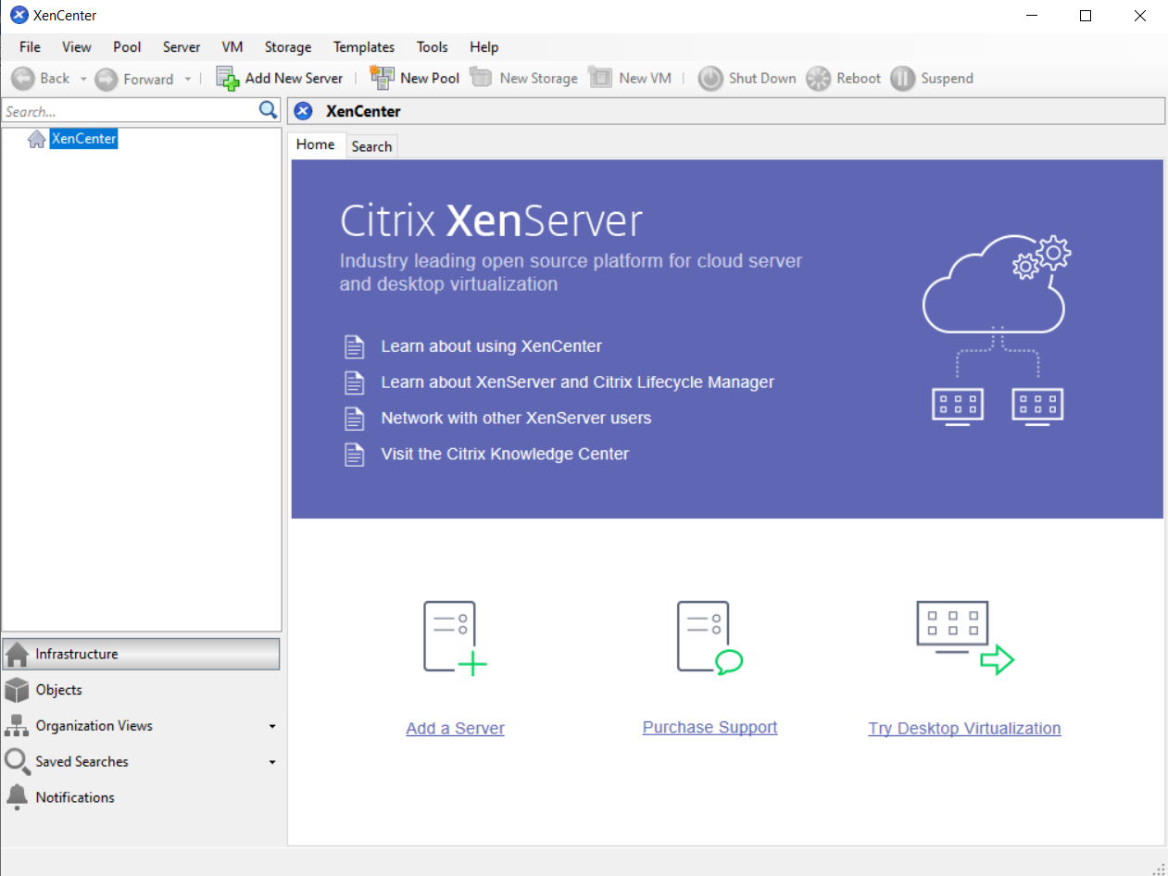

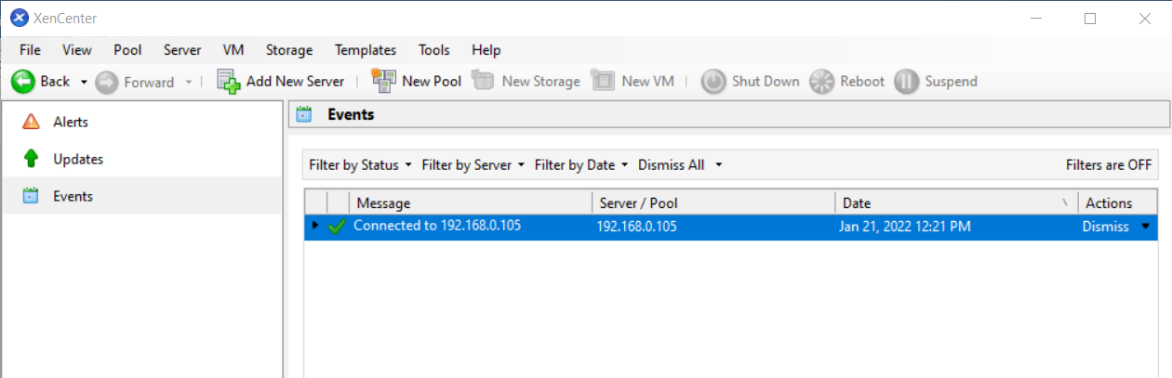

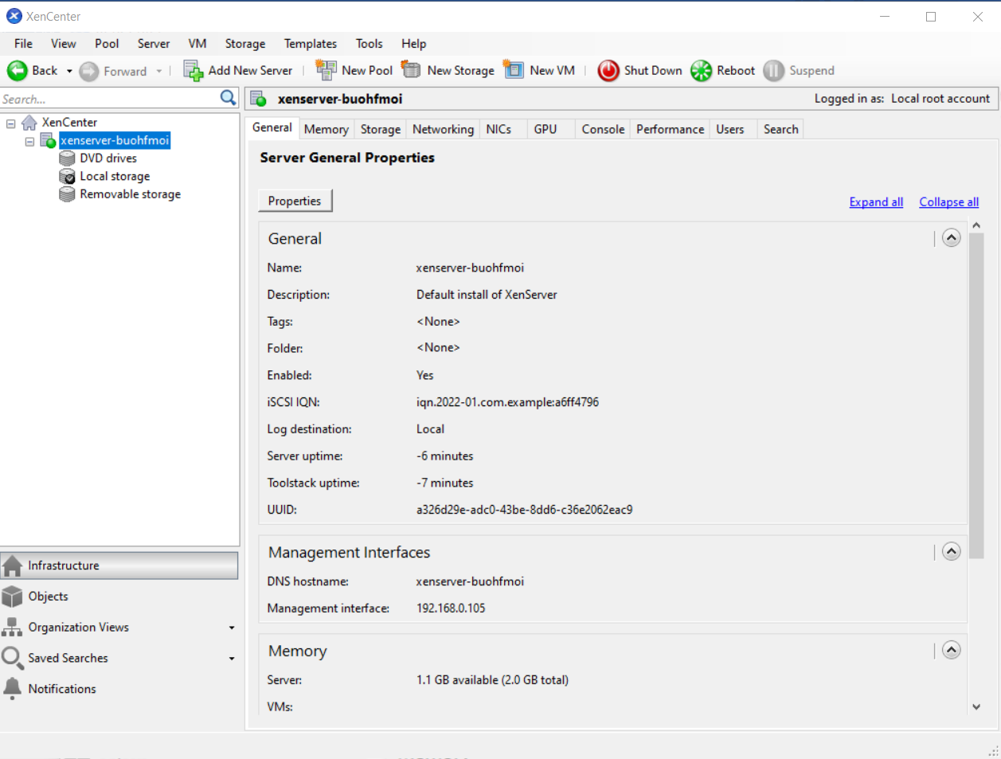

**XenCenter:**

**Questions:**

1. What is the difference between XEN and VMWare?

|  |  |
| --- | --- |
| **XEN** | **VMWare** |
| Open-source virtualization server | Provides virtualization software |
| Can run lesser virtual machines with the same hardware as compared to VMWare | Can run more virtual machines with the same hardware as compared to Xen |
| No Dynamic Resource Allocation | Provides dynamic resource allocation |
| Needs to modify the OS it is running on | No need |
| Lesser performance | Slightly better performance |
| Is less expensive | More expensive |

1. The hypervisor acts like a traffic cop, directing hardware access and coordinating requests from the guest operating systems.
   1. True
   2. False
2. XEN hyperisor does not support VM migration.
   1. True
   2. False
3. XEN hypervisor works on multiple cloud platforms.
   1. True
   2. False



**Outcomes:**

# CO1: Understand Virtualization.

**Conclusion: (Conclusion to be based on the objectives and outcomes achieved)**

Installed XenServer and XenCenter on my PC to understand virtualization.

**Grade: AA / AB / BB / BC / CC / CD /DD**

**Signature of faculty in-charge with dat****e**

(Autonomous College Affiliated to University of Mumbai)

KJSCE/IT/TYBTECH/SEM-VI/CC/2021-22

**References:**

**Books/ Journals/ Websites:**

1. http://www.xenproject.org

(Autonomous College Affiliated to University of Mumbai)